Dec 13, 2023
Ref: IIH/MD/2023/12/003

His Excellency,
The Executive Governor of Kwara State,
Government House,
Ahmadu Bello Way,
GRA, Ilorin, Kwara State

Your Excellency Sir,

REQUEST FOR APPROVAL TO RELEASE FUNDS FOR PAYMENT OF KWARA STATE GOVERNMENT GOOGLE WORKSPACE EMAIL & COLLABORATION TOOLS FOR
ENTIRE YEAR JAN-DEC 2024

I write to request the funds for 1 year renewal of the GSuite (Google Workspace Collaboration Tools) email addresses for Kwara State Principal officers for the period of Jan 2024 – Dec 2024. The last request was made at the rate of N900/$, today it’s N1250/$. Due to the fact that these costs are all billed in dollars and the recent increase of the dollar against the naira, I humbly ask this be treated quickly before any further inflation. It is also recommended we pay for the entire year up front instead of biannually.

SN | DESCRIPTION | QTY | RATE | DURATION | PRICE ($) | PRICE (N)*
 | Kwara State .gov Email
1 | Google Workspace Business Edition | 80 users | $12/user | 12 months  Jan-Dec 2024 | 11,520 | 14,400,000
2 | Service Charge + VAT 20%** |  |  |  |  | 2,880,000
 | GRAND TOTAL |  |  |  |  | 17,280,000

* This conversion was done at the current market rate of USD1 = NGN1250 as at Dec 13, 2023
** Service charge is to cover statutory government deductions as the costs are paid to Google, a third party vendor

I anticipate prompt payment so as to avoid disruption of service and continued smooth communication and collaboration within the State Government.

Yours sincerely,
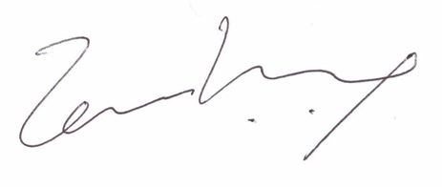
Temi Kolawole
ag. Managing Director

